# Concept Document: Re-imagining Public Spaces: Exploring the art of the possible for a new breed of municipal practitioner





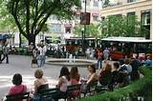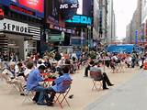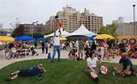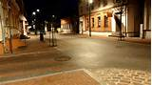

## Purpose of this Document

The intention of this document is to crystallize the thinking around the need for learning exchanges between municipal practitioners within the eThekwini Municipality and beyond in order to begin a conversation on re-thinking and re-imagining public spaces.

It spells out why the need for such dialogues are both important and timely, identifies opportunities that can be secured to promote the learning agenda, identifies roles and responsibilities of the key stakeholders and suggests some timeframes consideration.

## Why the need for dialogue?

We find ourselves at an important juncture in the development arena today. Whereas issues of public space management and people-centric space planning would never have been on the radar even a decade ago, this important issue is now on the international agenda. The UNHABITAT has taken up with cause with the preparation of a Global Toolkit on Public Space at their expert group meeting in Jan 2014, in Italy exploring ideas for more sustainable urban development. The UCLG has engaged in the dialogue around the charter and the eThekwini Municipality that is presiding the UCLG Committee on Urban Strategic Planning (USP)is interested to further cooperate in this process. It is anticipated that the debate and engagement on public space raised in the international agenda, particularly in Europe and US and Durban will be done through the vehicle of the UCLG USP Committee.

The Toolkit is based on a charter for public space developed by the National Italian Institute of Urbanism that has been adopted and applied by the city of Naples. Additionally, It is of utmost importance to reflect in this topic in African cities, where much urban development is taking place. This is aligned to the United Nations 2016 Sustainable Development Goals (previously MDGs) and the findings of 2012 State of the World Cities Report.

C:\Users\Bongumusa.Zondo\AppData\Local\Microsoft\Windows\Temporary Internet Files\Content.Outlook\SQDW23Z6\20yrs Logo.tif

As a municipality, there has been a growing recognition of the need to begin to explore new and more creative ways of thinking about, planning for and implementing public space management. Through exciting collaborative efforts facilitated through the Imagine Durban initiative, some demonstration projects have begun to introduce the public space debate on the urban management agenda. However, clearly more can be done and it is contended that a compelling platform for re-thinking space, is a learning engagement that begins to hold out new models of public.

It is envisaged that through the dialogues the following key objectives can be realized:

**INTERNAL TO THEKWINI**

1. To contribute towards the development of a framework / policy / strategy that is informed by a home-grow position paper that reflects the Southern African context
2. To explore the preparation of a user-friendly toolkit for the more creative design and use of public space.
3. To encourage eThekwini line departments with the actual implementation of the development plan
4. To begin to encourage the formation of partnerships that improve the use of public spaces
5. To raise awareness among municipal departments linked to urban planning such as housing, infrastructure and others to consider public space as a central piece of urban development.

**EXTERNALLY**

1. To initiate an ambitious process of changing mindsets with the view to improving our public open spaces.
2. To raise awareness and building knowledge about more effective uses of public space and showcase the value of space
3. To elevate the status of public spaces in urban areas
4. To consolidate the positioning of Durban as a centre of learning through the area of public space
5. To contribute towards making serious inputs into the UNHabitat Planning Guideline document by inserting a section on the role of public space in Planning
6. To promote the work and agenda of the UCLG committee on urban

strategic planning, also deepening actions around the “walking agenda” and accessibility of the city

1. To collaborate with UCLGA through the learning and promotion of

public space interventions in African cities

**Key Learning Themes**

1. Concept of Public Space (scene setting with reference to UN-HABITAT toolkit and Learning Note from Seminar)
2. Safety through design of Public Spaces (including disaster management and resilience)
3. Stakeholder Engagement
4. Public spaces as catalyst for socio economic transformation (including food security)
5. Creating inclusive Public Spaces: Arts, history, heritage, recreation
6. Planning for architectural, urban design, considerations for vibrant accessible public spaces.
7. Public Space Governance and Policy
8. Innovations for financing of public spaces

**3. What Opportunities present themselves for Learning?**

The intention is to begin a systematic process beginning with internal stakeholders within the municipality to raise awareness, create an appetite for doing things differently in relation to urban space management and to use the outputs created at such an internal seminar to inform a national learning exchange and finally an international learning event to be structured as a side-bar to the Architecture Congress in August 2014. The idea is to ultimately inform a new policy on urban space management in eThekwini and more importantly shape the development of the UN Habitat Planning guidelines / UN public space framework.

The spatial and social dimension of managing public space will be addressed, inspired by urban design and planning guidelines (quantity, quality, access), as well as participatory approaches of “placemaking and appropriation” (use, walking, street vending, community actions, health) emphasizing on the particularly African needs and opportunities.

**Schematic Process Flow:**

A four-phased approach is suggested with each phase informing the next. The first three phases are punctuated with learning events over a five month period, as indicated below. The intention is to start with an internal eThekwini seminar during which a draft Position Paper will be developed. This is important as a clear terms of reference defining what is meant by Public Space, how it is viewed in the African context, and how the elements suggested in the UN Framework on Public Space can come together to present an integrated response that can guide African practitioners.

Thereafter international speakers that will present at a national event will be mobilized at the World Urban Forum in April 2014 and an attempt made at the event to garner support and begin a database of ideas and good practice. Ultimately the vision is to have an international learning exchange at the Architecture Congress in August 2014, where the “All Africa Design Award for most Creative Use of Public Space” could be launched.

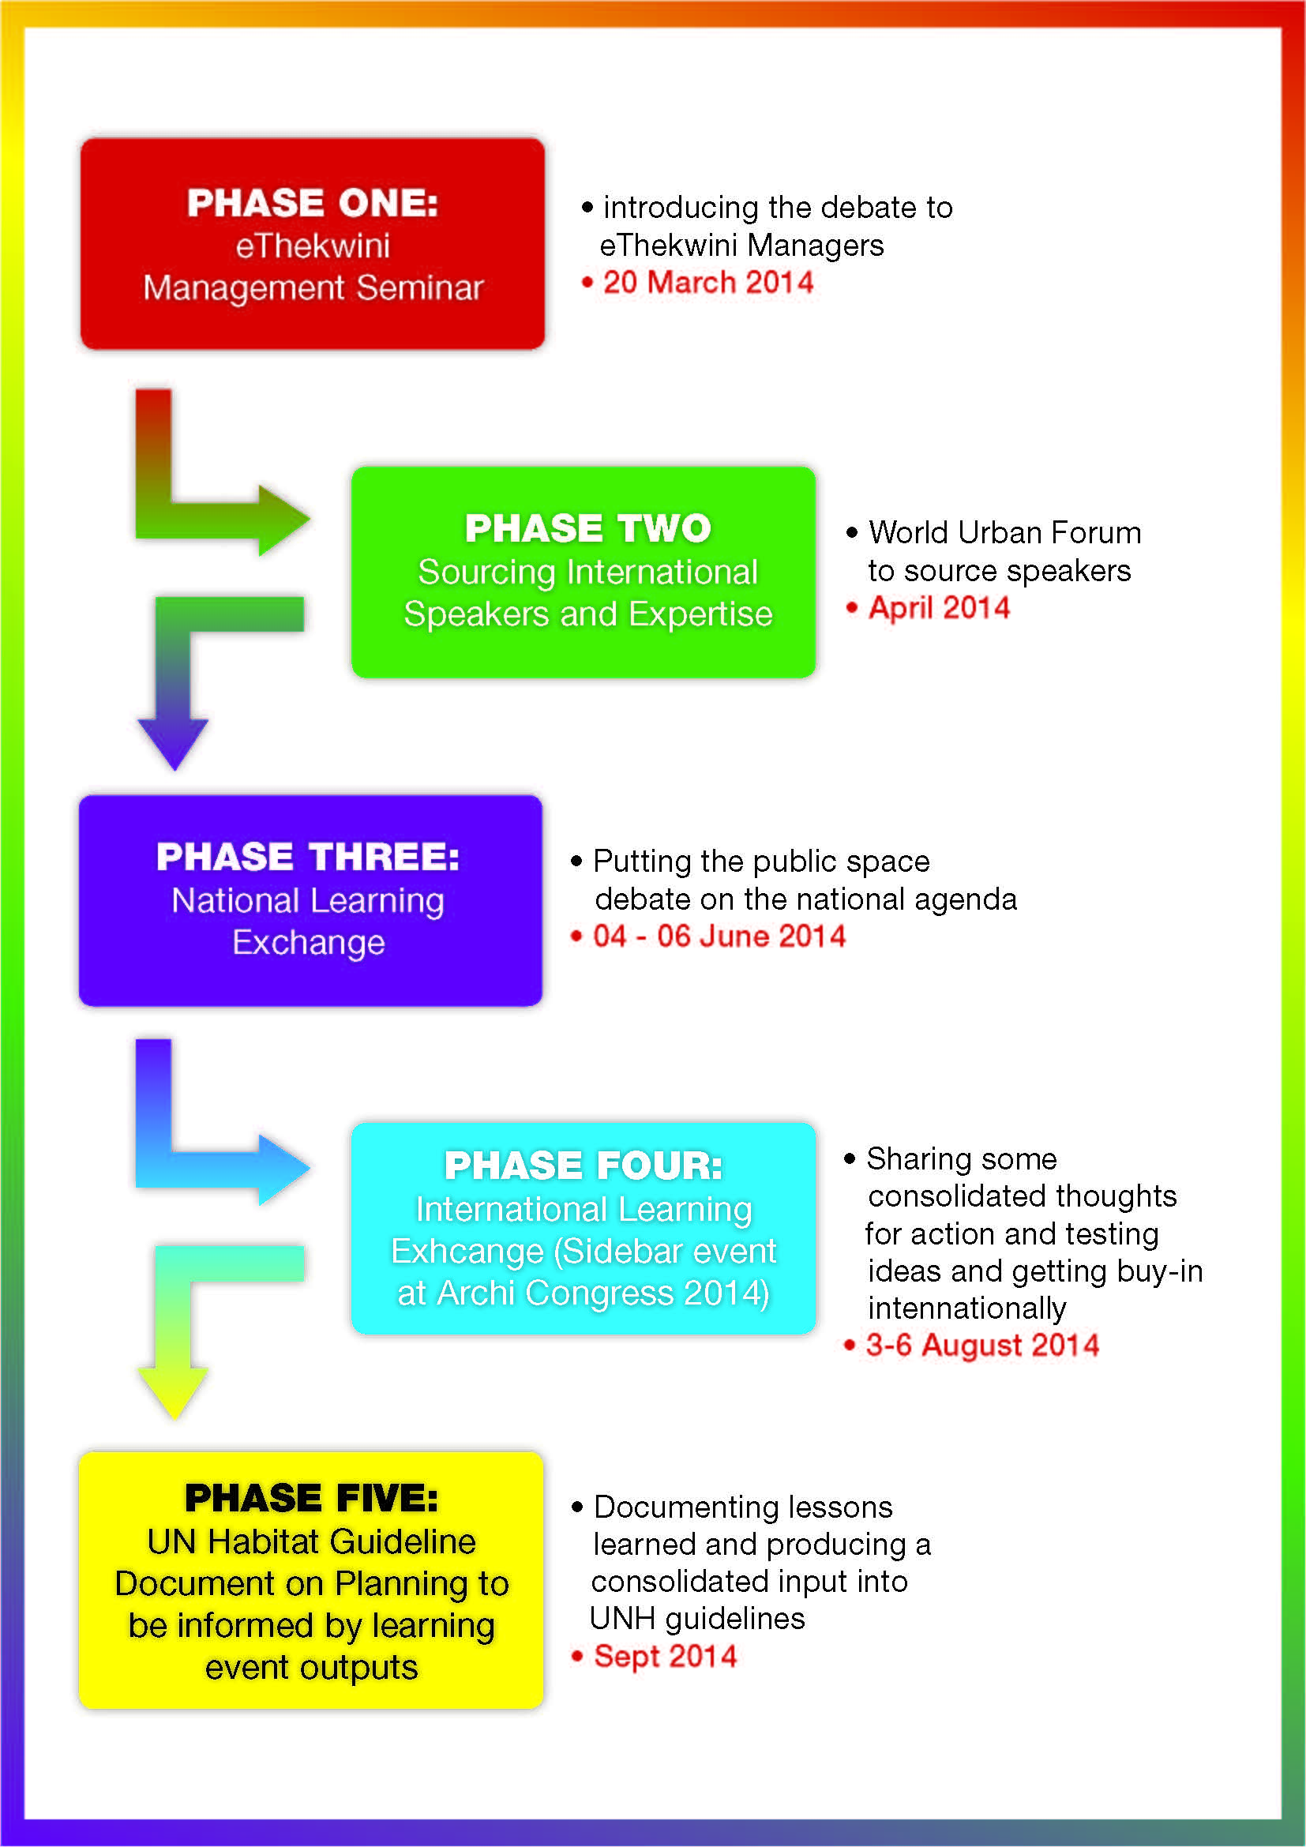

**4. Defining our Roles and Responsibilities**

**Program Driver:**

Imagine Durban has a clear mandate to hold a new urban imaginary for the City. Through the Council-adopted Imagine Durban Plan the issue of public space management is a cross-cutting theme that is embedded in the plan. More importantly, the Imagine Durban Plan is structured for implementation commencing with Demonstration Projects (e.g. Bulwer Park) and institutionally structured with Program Managers for each sector ( eThekwini, business, Schools, Tertiary, NGOs ,etc.) The internal sector – i.e. eThekwini is a key sector as inspiring and changing mindsets of internal officials is part of the mandate of this program.

Given this institutional location, Imagine Durban will be responsible for driving the program; ensuring that events happen, seeking funding, identifying players, managing the logistics of the events and ensuring the support from key partners (identified below)

**Program Partners**

**Learning Partner: MILE**

MILE will be responsible for leading the conceptualization of the learning event and supporting all learning aspects of the events. This will include facilitation, documentation, video-recording and evaluation.

**Content Partners: eThekwini Line Departments**

It is important that while Imagine Durban drives the program, that key departments responsible for implementation take ownership of, and feel part of this program, as they have expertise and knowledge in the field and ultimately will have responsibility for implementation.

Key Departments in municipality will include:

* Parks and Recreation
* Architecture
* Planning
* Human Settlements
* Environmental Planning & Climate Protection Department
* Real Estate : Land Transactions
* Legal Department
* ETA
* Museums, Libraries

From these Departments the lead content departments will be prioritized to help prepare a Position Paper that will be deliberated on at the Management Seminar. NOTE: the IGR Department will play a key role in inviting African partners.

**National and International Partners**

**National Partners**

* SACN
* SALGA
* SAPI / SACPLAN
* KZNCOGTA

**International Partners**

* UCLG through the committee on Urban Strategic Planning
* UCLGA
* Commonwealth LG Forum

**NGOs**

* Future Cities
* DALA
* Children’s Rights Centre, etc.

**Tertiary / Research Partners**

* Durban University of Technology (DUT)
* University of KwaZulu-Natal ( UKZN)
* Mangosuthu University of Technology (MUT)
* University of Pretoria (UP)
* Centre for African Studies

**5. Suggested Budgets & Resources**

The eThekwini Municipality through its Imagine Durban Project and MILE working with strategic partners will source funding for the different phases of the International and National learning exchange activities.

**6. Draft Programme**

|  |  |  |  |  |  |  |  |  |  |
| --- | --- | --- | --- | --- | --- | --- | --- | --- | --- |
| DAY 1 | **WEDNESDAY, June 04, 2014** | | | | | | | | |
| 8:00 – 8:30 | **REGISTRATION: TEA AND COFFEE** | | | | | | | | |
| **SESSION ONE** | **OFFICIAL OPPENING, WELCOME AND KEYNOTE ADDRESS** | | | | | | | | |
| 8:30 – 09:45 | **PUBLIC SPACES LEARNING EXCHANGE** | **SETTING THE CONTEXT: Facilitator: Mr. Sogen Moodley: Senior Manager: MILE** | | | | | | | |
| Ground Rules and Quick Introductions and Expectations | Mr. Sogen Moodley | | MILE Facilitator | | | | eThekwini Municipality |
| 9:45 – 09:00 | Official Opening and Welcome, Keynote | TBC | | Office of the City Manager | | | | eThekwini Municipality |
| 09:00- 09:10 | Message of Support | Dr Moyo Or Dr Gumede | | Deputy City Manager: | | | | Ethekwini Municipality |
| 09:1O – 09:25 | Background to Public Spaces Initiative in Ethekwini (Imagine Durban and UCLG Partnership | Mr. Bongumusa Zondo and Sara Hoeflich | | Senior Manager : IDP and Secretariat UCLG (Sara after you speak you can introduce William) | | | | eThekwini Municipality |
| 09:25 – 10: 00 | Keynote Address and Questions of Clarity | William Carmago | | Guest Speaker : City of Bogota | | | | Bogota |
| 10:00 – 10:15 | **TEA AND COFFEE BREAK** | | | | | | | |
| **SESSION TWO:** | **EXPLORING THE CONCEPT OF PUBLIC SPACE**  **Facilitator:** | | | | | | | |
| 10:15 – 10:40 | The KwaZulu-Natal Municipality | TBC | | | TBC | | eThekwini Municipality | |
| 10:40 – 11:00 | Experiences from other municipalities in South Africa | TBC | | | TBC | | TBC | |
| 11:00 – 11:30 | Questions and Discussions | Facilitator | | | MILE Facilitator | | eThekwini Municipality | |
| 11:30- 12:45 | Facilitated Table Discussions | Facilitator | | | ALL | | ALL | |
| 12:45 – 13:45 | **LUNCH** | | | | | | | |
| **SESSION THREE** | **Panel Discussion : People Centred Public Space: Lead Thought Leader: Doung Jahanger Facilitator:** | | | | | | | |
| 13:45 – 15:30 | Theme 5: People-Centred Public Space :Panel discussion: Topic to be confirmed | | Mr. Doung Jahanger. David Bravo (CCCBarceona) Vanessa (PPS) , Richard Dobson,  Jean Pierre Mbassi (to do the moderation/ summation of the plenary session | | |  | DALA | |
| 15: 30- 15:45 | **WORKING TEA BREAK** | | | | | | | |
| 15: 30- 15: 45 | Questions and Discussions | | Facilitator | | |  | ALL | |

|  |  |  |  |  |  |  |
| --- | --- | --- | --- | --- | --- | --- |
| DAY2 | **THURSDAY, JUNE 05, 2014** | | | | | |
| 8:00 – 8:30 | **Arrival, Tea and Coffee** | | | | | |
| **SESSION FOUR** | **RECAP OF DAY 1:**  **Facilitator: Puven Akkiah** | | | | | |
| 8:30 – 09:00 |  | Summary of Lessons Learnt from DAY 1 and Programme for the Day | Facilitator | MILE | eThekwini Municipality | |
| 08:50- 09:00 | Objectives of Day 2 | Bongumusa Zondo | Senior Manager: Imagine Durban | eThekwini Municipality | |
| **SESSION FIVE** | **SITE VISIT: SHOWCASING STRATEGIC PLANNING FOR PUBLIC SPACES: THE DURBAN PROMENADE** | | | | |
| 09:00 – 09:15 |  | Boarding the Shuttles | ALL | ALL | | ALL |
| 11:30 – 12:15 | **PUB**  **L**  **I**  **C**  **S**  **PACE**  **S**  **LX** | Observations and Discussions from the Site Visit | Facilitator |  | |  |
| 12:15 – 12:30 |  |  |  | |  |
| 12:30-12:40 | Departure to Venue | ALL | ALL | | ALL |
| 12:40 – 12:50 |  |  |  | |  |
| 13:00-13:45 | **LUNCH 2** | | | | |
| **SESSION SIX** |  | **PUBLIC SPACES SAFETY**  **Facilitator: Mr. Martin Xaba** | | | | |
| 1 3 : 4 5 -1 4 : 4 5 |  | Panel Discussion | **Introduction UN Habitat on the public space toolkit and the safer cities**  Maria from Port Allege to do Summary of Key Points |  | |  |
| 1 4 : 4 5 – 15 : 0 0 | Questions of Clarity |  |  | |  |
| 15:00-16:00 | **TEA BREAK** | | | | |
| 16:00 – 16:45 | Table Discussions |  |  | | ALL |

|  |  |  |  |  |  |  |  |
| --- | --- | --- | --- | --- | --- | --- | --- |
| DAY 3 | **FRIDAY, June 06, 2014** | | | | | | |
| 8:00 – 8:30 | **ARRIVAL: TEA AND COFFEE** | | | | | | |
| **SESSION TEN** | **RECAP OF DAY 2** | | | | | | |
| 8:30 – 09:45 | **COMMUNITY ENGAGEMENT LEARNING EXCHANGE** |  | | | | | |
| Lessons Learnt from DAY 2 | Mr. Sogen Moodley | MILE Facilitator | | | eThekwini Municipality |
| Objectives of DAY 3 |  |  | | |  |
| **PUBLIC SPACE GOVERNANCE and POLICY including Financing :** | | | | | |
| 9:45 – 09:00 | UH Habitat Charter on Open Space | Pietro Garau, Italy |  | | |  |
| 09:00- 09:10 |  |  |  | | |  |
| 09:1O – 09:25 |  |  |  | | |  |
| 10:30 – 10:45 | **TEA AND COFFEE BREAK** | | | | | |
| **SESSION ELEVEN:** | **STAKEHOLDER ENGAGEMENT IN PUBLIC SPACE Facilitator:** | | | | | |
| 10:45 – 11:45 | Project for Public Spaces | Vanessa September | | Board Member | PPS | |
| 11:45 – 12:00 |  |  | |  |  | |
| 11:00 – 11:30 | Questions and Discussions | Facilitator | | MILE Facilitator | eThekwini Municipality | |
| 11:30- 12:45 | Facilitated Table Discussions | Facilitator | | ALL | ALL | |
|  | Wrap Up- and Way Forward | Facilitator | |  |  | |
| 12:45 – 13:45 | **LUNCH – End of the Learning Exchange** | | | | | |