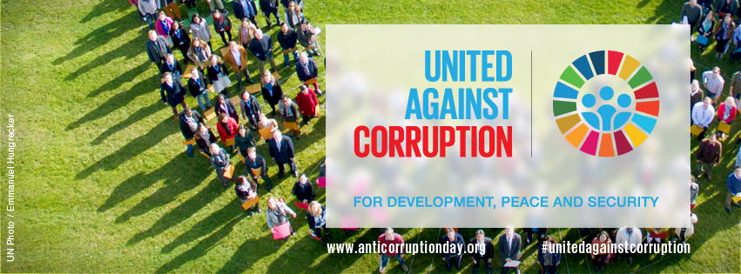

Paris statement
on the occasion of the International Anti-corruption Day
9th December 2016
#localgov4transparency
In 2013, the General Assembly of the United Nations designated 9th of December as the International Anti-corruption Day. On the occasion of the Open Government Partnership Summit organized by the Government of France, the signatory institutions would like to express their commitment to work towards more transparent, accountable and participative cities and territories.
In the words of the UN Secretary General, Mr. Ban-Ki-moon, “Elected officials, mayors, governors and councillors are at the forefront of the battle for sustainable development. We need strong, capable and accountable local government if we are to achieve the 2030 Agenda for Sustainable Development”.
Cities are places of opportunity and social advancement; and local and regional governments are the first ones responsible for ensuring that the challenges of urban life become opportunities for all. Access to affordable and quality public services is essential to achieving this. Local government needs to make sure that resources that should be devoted to schools, health clinics and other vital public services, reach those who need them the most.
The undersigned institutions fully commit to the implementation of Sustainable Development Goal sixteen Goal 16 and to “Promote peaceful and inclusive societies for sustainable development, provide access to justice for all and build effective, accountable and inclusive institutions at all levels”.
Attaining SDG 16 requires local and territorial governments to be more effective, open and accountable to citizens. For decades, local and regional governments have led efforts towards the adoption of new forms of inclusive decision-making, such as participatory budgets or participatory urban planning. There is a clear correlation between transparency and the elimination of corruption and bribery in all its forms. This requires creating effective, accountable and open institutions, ensuring the adoption of decisions that meet the needs of all citizens and ensuring public access to information.
The New Urban agenda approved by the UN member states in Quito last October calls for transparency in 16 instances, including the need for accountably financial mechanisms, spending and resource allocation, management and use of land, procurement and regulation of transport, impact of local investments and contractual relationships with service providers. We would like to renew our endorsement of the principles established by the Quito Urban Agenda and manifest our commitment to its implementation at local level.
On this International Anti-Corruption Day, we firmly reject all forms of corruption and call for local and regional governments all over the world to renew their belief in the principles of transparency, accountability and good governance.

Paris City Hall, December 9th 2016

Endorsed by:
- City of Paris (France)
- City of Tbilisi (Georgia)
- City of Milan (Italy)
- City of Govan Mbeki (South Africa)
- UN-Habitat, Local government and decentralization Unit
- FMDV, Global fund for the development of cities
- UCLG-Africa, United Cities and Local Governments, Africa Section
- CEMR – Council of European Municipalities and Regions
- Commonwealth Local Government Forum
- FLACMA – Federation of Latin American Cities, Municipalities and Municipal Associations
- AIMF – International Association of French-speaking Mayors
- Metropolis
- Mercociudades
- UCLG ASPAC, United Cities and Local Governments, Asia Pacific Section
- SALGA, South African Local Government Association

